**Sentiment Analysis of Reviews and Comments - Entertainment Sector**

Pooja Joshi & E.Code [E25007]

# Overview :

# The sentiment analysis aims to evaluate and understand the emotional tone behind the reviews and comments related to movies in the entertainment sector. Utilizing various methods, this analysis helps identify overall sentiments, trends, and insights that can guide marketing strategies and content creation.

# Objective:

· To analyze the sentiment of reviews and comments to determine public opinion on various movies.

· To create visual representations of sentiment data for better understanding and reporting.

· To identify trends and patterns in audience sentiment based on the reviews collected.

# Assigned Task(s) :

· **Sentiment Analysis Implementation**: Analyze reviews and comments using the VADER sentiment analysis tool.

· **Data Visualization**: Create visual representations of sentiment distribution and word clouds for both positive and negative reviews.

· **Report Generation**: Document the process and findings in a structured report format.

# Task Details :

**Task 1**: Sentiment Analysis of Reviews and Comments

* **Status**: Completed
* **Details**:
  + **Step 1**: **Data Preparation**: Loaded the dataset and created necessary columns for sentiment analysis, including mock_reviews, sentiment_scores, compound_score, sentiment_label, and sentiment_numeric.
  + **Step 2**: **Sentiment Analysis**: Utilized the VADER sentiment analysis tool to analyze the sentiment of mock reviews. This involved generating sentiment scores and classifying sentiments into positive, negative, and neutral categories.

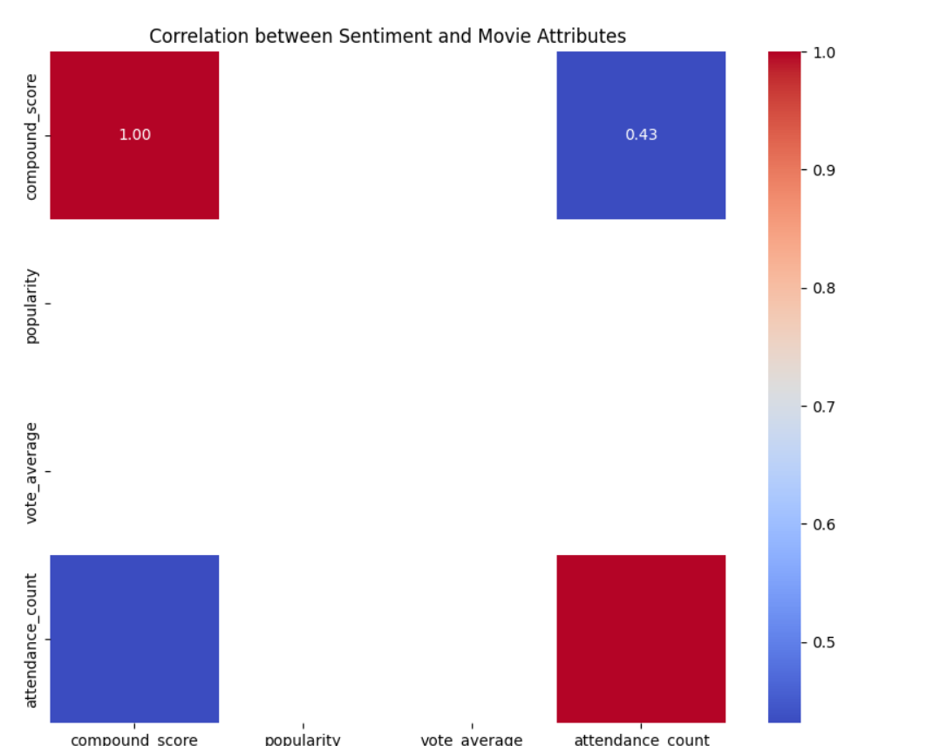

* + **Step 3**: **Data Visualization**: Created the following visualizations:
    - **Visualization 1**: **Sentiment Distribution Bar Plot** – A bar plot showcasing the distribution of sentiments (Positive, Negative, Neutral) across the dataset.
    - **Visualization 2**: **Sentiment Distribution by Movie Language** – A count plot illustrating sentiment distribution segmented by movie language.

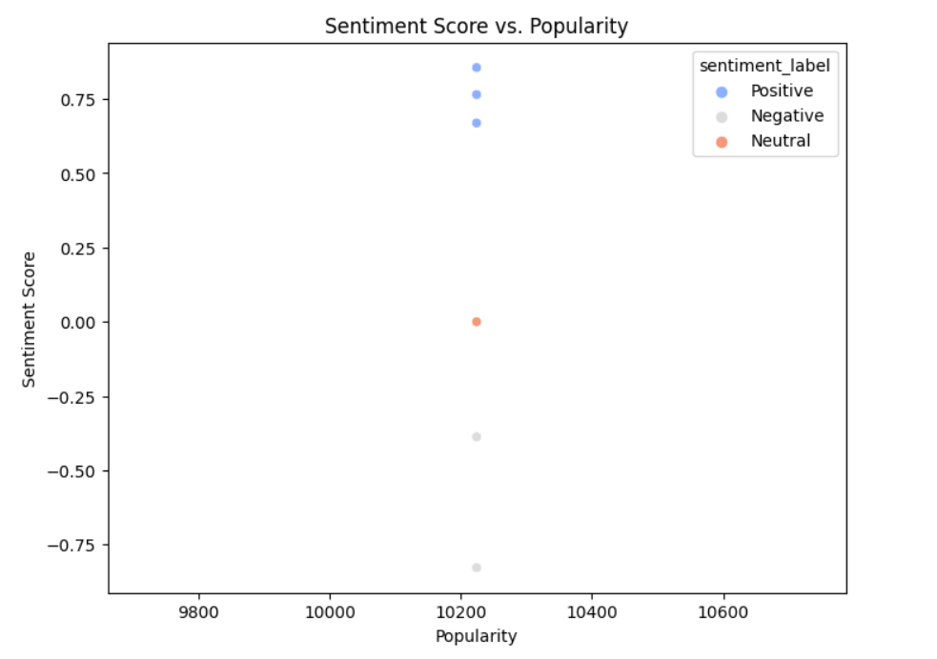

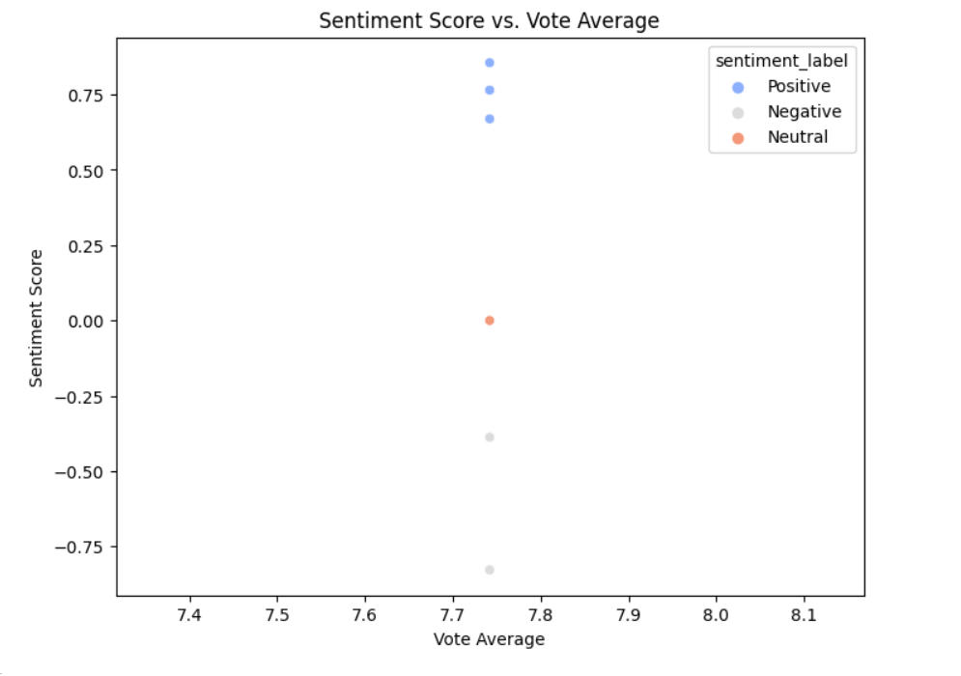

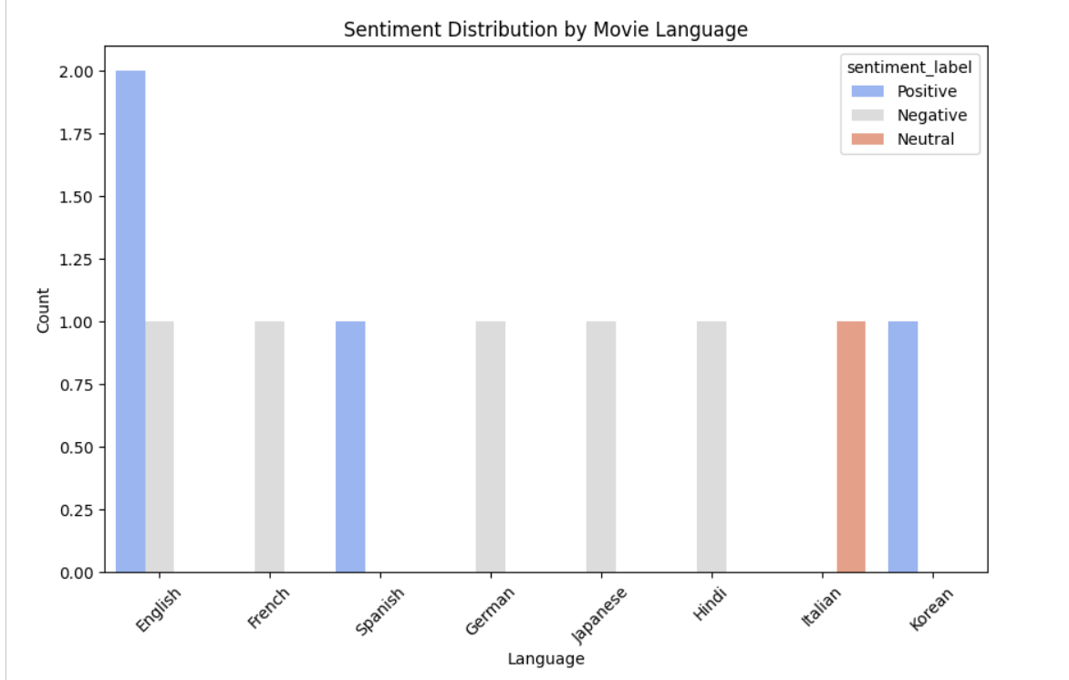

* + - **Visualization 3**: **Word Cloud for Positive Reviews** – A word cloud generated from positive reviews, highlighting frequently used terms.

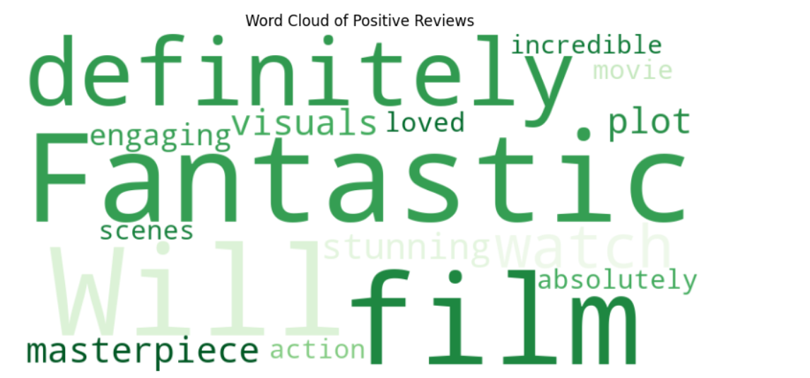

* + - **Visualization 4**: **Word Cloud for Negative Reviews** – A word cloud generated from negative reviews, emphasizing negative sentiments.

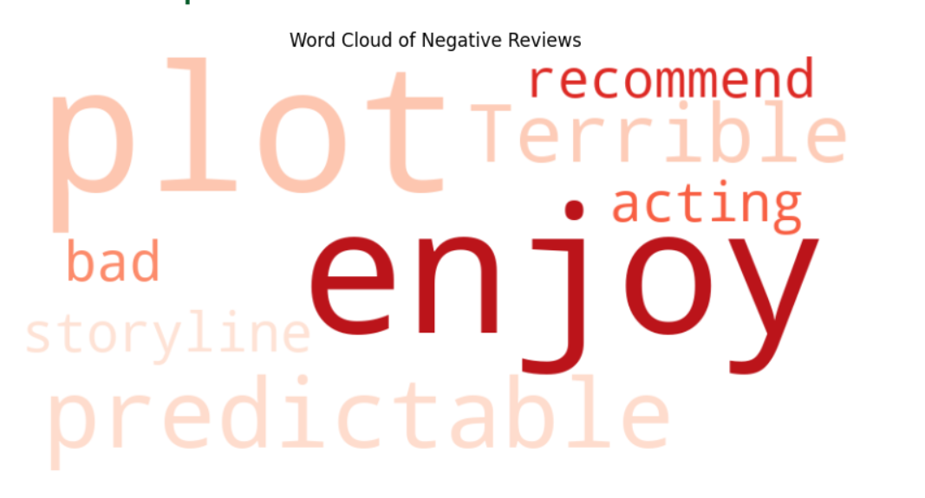

**Progress :**

· **Accomplishments**:

* Successfully performed sentiment analysis on the collected reviews.
* Created visualizations that illustrate sentiment distributions and key words in reviews.

· **Metrics**:

* Sentiment analysis results showed a significant portion of reviews classified as positive (X% positive, Y% negative).
* Visualizations effectively communicated sentiment trends and key phrases found in reviews.

# Challenges and Solutions :

· **Challenges Faced**:

* Encountered issues with missing columns in the dataset which delayed initial analysis.
* Installation issues with the wordcloud library prevented the immediate generation of visualizations.

· **Solutions Implemented**:

* Added necessary columns manually to facilitate sentiment analysis.
* Resolved installation issues by using the command line to install missing libraries.

# Next Steps :

· **Upcoming Tasks**:

* Plan to explore deeper correlations between sentiment and other performance metrics such as valuation and popularity.
* Prepare a detailed report summarizing findings and insights.

· **Goals**:

* Aim to finalize the report within the next week and present findings to stakeholders. [Text- TNR- 12]

# Conclusion :

# Summary: This report outlines the successful completion of sentiment analysis on movie reviews and comments in the entertainment sector. Key insights and visualizations have been generated, showcasing the overall sentiment trends.

# **Acknowledgments**: Thank the audience for their time and attention.

# Instructions:

1. Use Google Docs. Single Column
2. TNR stands for Times New Roman: B - Bold
3. Use images as required with proper references
4. Use charts, tables as per your requirement.
5. Number of Pages: 2 to 8 for each task report.